// ------------------- ASSIGNMENT 1 -------------------
// Creating a database name homecare_db
CREATE DATABASE homecare_db
WITH
OWNER = postgres
ENCODING = 'UTF8'
LOCALE_PROVIDER = 'libc'
CONNECTION LIMIT = -1
IS_TEMPLATE = False

// Creating schema hc
CREATE SCHEMA hc
AUTHORIZATION postgres;
// Creating Extention for UUID
CREATE EXTENSION IF NOT EXISTS "uuid-ossp";
//Created Table Users
CREATE TABLE hc.users (
user_id UUID PRIMARY KEY DEFAULT uuid_generate_v4(),
first_name varchar(30) not null,
last_name varchar(40) not null,
email varchar(50) unique not null,
password varchar(255) not null,
created_by UUID REFERENCES hc.users(user_id) on DELETE NO ACTION,
created_date timestamptz not null default now(),
modified_by UUID REFERENCES hc.users(user_id) on DELETE NO ACTION,
modified_date timestamptz ,
is_active boolean not null default TRUE,
is_deleted boolean not null default FALSE,
birth_date date,
address varchar(255) not null,
mobile_number varchar(250) not null
);
// Entering 10 dummy entaries
// For First user
INSERT INTO hc.users (
first_name,
last_name,
email,
password,
created_by,
birth_date,
address,
mobile_number
) VALUES (
'John',
'Doe',
'john.doe@example.com',
'$2a$10$abcdef123456',
NULL,
'1990-01-15',
'123 Main St, New York, NY',
'1234567890'
);
// For Other users
INSERT INTO hc.users (
first_name,
last_name,
email,
password,
created_by,
birth_date,
address,
mobile_number
) VALUES ('Jane','Smith','jane.smith@example.com','$2a$10$abcdef123457','19e77c21-3459-4c12-a566-f452b9336b50','1988-05-22','456 Oak Ave, Los Angeles, CA','2345678901'),
('Michael','Brown','michael.brown@example.com','$2a$10$abcdef123458','19e77c21-3459-4c12-a566-f452b9336b50','1992-09-10','789 Pine Rd, Chicago, IL','3456789012'),
('Emily','Davis','emily.davis@example.com','$2a$10$abcdef123459','19e77c21-3459-4c12-a566-f452b9336b50','1995-12-03','321 Maple St, Houston, TX','4567890123'),
('Daniel','Wilson','daniel.wilson@example.com','$2a$10$abcdef123460','19e77c21-3459-4c12-a566-f452b9336b50','1985-07-19','654 Cedar Ln, Phoenix, AZ','5678901234'),
('Sophia','Taylor','sophia.taylor@example.com','$2a$10$abcdef123461','19e77c21-3459-4c12-a566-f452b9336b50','1993-03-27','987 Birch Blvd, San Diego, CA','6789012345'),
('James','Anderson','james.anderson@example.com','$2a$10$abcdef123462','19e77c21-3459-4c12-a566-f452b9336b50','1989-11-11','159 Walnut Way, Dallas, TX','7890123456'),
('Olivia','Thomas','olivia.thomas@example.com','$2a$10$abcdef123463','19e77c21-3459-4c12-a566-f452b9336b50','1996-06-08','753 Spruce Ct, Austin, TX','8901234567'),
('William','Moore','william.moore@example.com','$2a$10$abcdef123464','19e77c21-3459-4c12-a566-f452b9336b50','1987-02-14','852 Aspen Dr, Seattle, WA','9012345678'),
('Ava','Martin','ava.martin@example.com','$2a$10$abcdef123465','19e77c21-3459-4c12-a566-f452b9336b50','1994-08-30','951 Cherry Pl, Boston, MA','0123456789');

// Section 5

// Fetch all users
select * from hc.users;
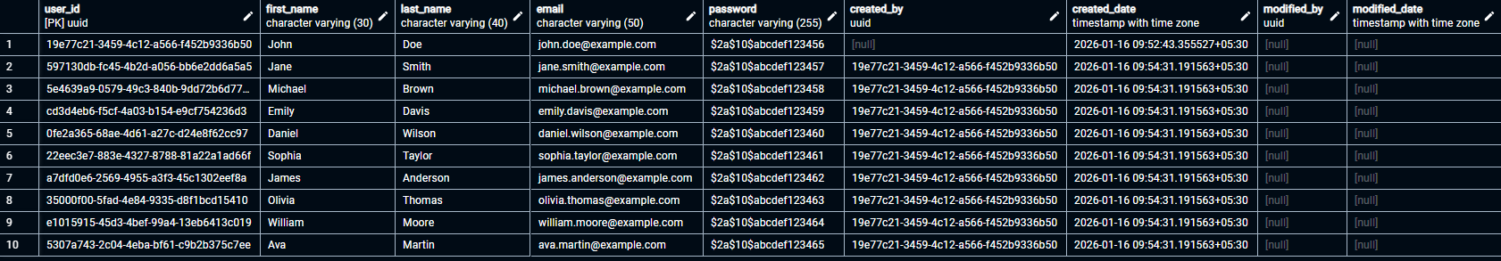
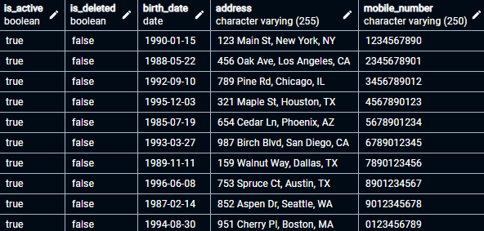

// Concat
select concat(first_name,' ' ,last_name) as name, email from hc.user

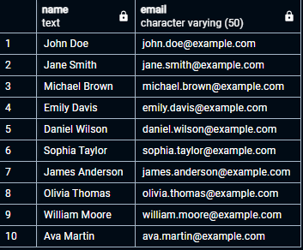

// To fetch all inactive
update hc.users set is_active = false where user_id = 'bc9f858f-bc1c-4658-b040-9358ec9af8e2';

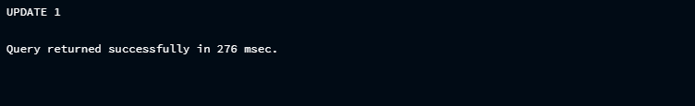

// Users whose first_name starts with 'A' and last_name ends with 'i'
select * from hc.users where first_name like 'A%' and last_name like '%i';
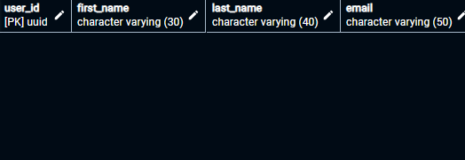

// Users whose email contains '@example'
select user_id , email from hc.users where email ilike '%@example%';

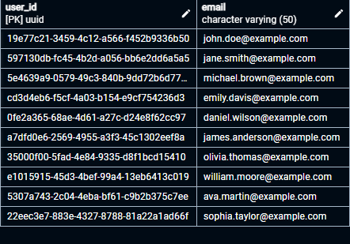

/ Case-insensitive search for first_name starting with 'A
select user_id , email from hc.users where first_name ilike 'A%'

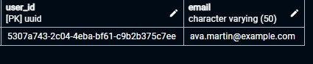
// Users ordered by created_date (descending)
select * from hc.users order by created_date desc;
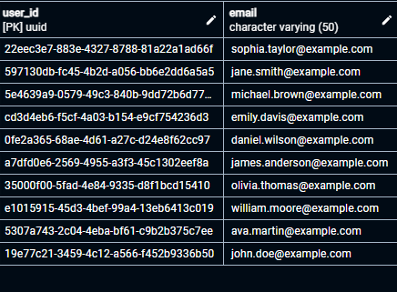
// Top 5
select user_id , email from hc.users order by created_date desc limit 5 ;
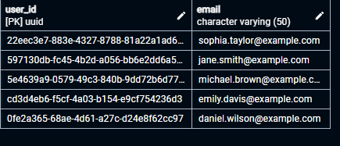
// Second page of results (5 records per page
select user_id , email from hc.users offset 5 limit 5;
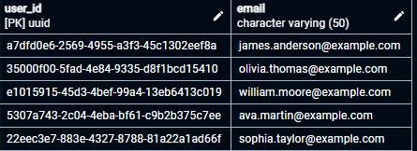

// ------------------- ASSIGNMENT 2 -------------------

​// TABLES CREATED
//ROLE

CREATE TABLE hc.role(
role_id BIGSERIAL PRIMARY KEY,
role_name VARCHAR(50) UNIQUE NOT NULL,
created_by UUID REFERENCES hc.users(user_id) on DELETE NO ACTION,
created_date timestamp not null default now(),
modified_by UUID REFERENCES hc.users(user_id) on DELETE NO ACTION,
modified_date timestamp,
is_deleted BOOLEAN,
is_active BOOLEAN
);
//SERVICE_TYPES

CREATE TABLE hc.service_types(
service_id BIGSERIAL PRIMARY KEY,
service_name VARCHAR(255) UNIQUE NOT NULL,
created_by UUID REFERENCES hc.users(user_id) on DELETE NO ACTION,
created_date timestamp not null default now(),
modified_by UUID REFERENCES hc.users(user_id) on DELETE NO ACTION,
modified_date timestamp,
is_deleted BOOLEAN,
is_active BOOLEAN
);
//CATEGORY

CREATE TABLE hc.categories(
category_id BIGSERIAL PRIMARY KEY,
category_name VARCHAR(255) UNIQUE NOT NULL,
created_by UUID REFERENCES hc.users(user_id) on DELETE NO ACTION,
created_date timestamp not null default now(),
modified_by UUID REFERENCES hc.users(user_id) on DELETE NO ACTION,
service_id BIGSERIAL REFERENCES hc.service_types(service_id) on DELETE NO ACTION,
modified_date timestamp,
is_deleted BOOLEAN,
is_active BOOLEAN
);

// SUB-CATEGORIES
CREATE TABLE hc.sub_categories(
subcat_id BIGSERIAL PRIMARY KEY,
subcat_name VARCHAR(255) UNIQUE NOT NULL,
subcat_description VARCHAR(255),
price MONEY NOT NULL,
duration TIME NOT NULL,
commision SMALLINT NOT NULL,
images VARCHAR(255) , -- MAKE IMAGE TABLE AND GIVE REFRENCE TO IT
is_cleaning_included BOOLEAN DEFAULT FALSE,
modified_by UUID REFERENCES hc.users(user_id) on DELETE NO ACTION,
created_by UUID REFERENCES hc.users(user_id) on DELETE NO ACTION,
service_id BIGSERIAL REFERENCES hc.service_types(service_id) on DELETE NO ACTION,
category_id BIGSERIAL REFERENCES hc.categories(category_id) on DELETE NO ACTION,
modified_at timestamp,
created_at timestamp,
is_deleted BOOLEAN DEFAULT FALSE,
is_active BOOLEAN DEFAULT TRUE,
is_available BOOLEAN DEFAULT FALSE
);

INSERT INTO hc.role(
role_name
) VALUES ('ADMIN'),('CUSTOMER'),('SERVICE_PARTNER');

